Data Representation: File Management
im_file_management.php — Information Management
Quotes….
The average worker loses now over two hours looking for misplaced documents and emails on their computer.
– K.J. McCory
… postponing file management creates a messy, unworkable system that costs time and efficiency.
– Annie Sisk
You should be consistent and descriptive in naming and organizing files so that it is obvious where to find specific data and what the files contain.
– Stanford Libraries
The best time to file a document is when you first create it. So get in the habit of using the "Save As" dialogue box to file your document as well as name it, putting it in the right place in the first place.
– Susan Ward
All the data on your hard drive consists of files and folders. The basic difference between the two is that files store data, while folders store files and other folders.
– Per Christensson
Use plain language to name your folders; you don’t want to be looking at this list of folders in the future and wondering what “TFK” or whatever other interesting abbreviation you invented means.
– Susan Ward
It's best to set up your file structure within one master folder; this makes backing up and moving stored files easier.
– K.J. McCory
Create other folders within these main folders as need arises. For instance, a folder called “Invoices” might contain folders called “2018”, “2017” and “2016”. A folder named for a client might include the folders "customer data" and "correspondence". The goal is to have every file in a folder rather than having a bunch of orphan files listed. Do not, however, create complex, deeply-layered folder structures. Wherever possible use descriptive file names instead.
– Susan Ward
The basic objective of a good filing system is to be able to find (what) you need quickly and economically, regardless of its format. The goal of a good filing system is to provide quick access to information.
– Sacramento State University
File names should make sense to all users and readily identify the type, purpose and basic content of each file.
– Annie Sisk
Proper organization of digital documents is especially critical in a shared environment - if one of your employees is absent (temporarily or permanently!) you should be able to easily locate any documents created or managed by that person.
– Susan Ward
Sometimes electronic documents are stored under a single file folder, which is similar to storing all paper office documents in one file cabinet drawer, with no hanging files or Manila folders to categorize them.
– K.J. McCory

include file backup plans in your file management system. Ideally, you should create multiple backup copies of your files. Those backups should be stored on various computers, at least one of which is not located on your workplace premises. Be sure to specify who makes backups, how often and with what technology in your computer file management system.
– Annie Sisk

Computer file management

Navigation Arrows
These arrows allow you to navigate through files / folders.
Use them as you would the arrow keys on your keyboard.

Path
This displays the path to the current selected item.
This also works as a 'breadcrumbs' trail - if you double click on one of the folders in the path the finder will make it the currently selected folder.
Below that the status bar tells you how many files you have selected, how many files are in the folder and the amount of free space left on your drive.

Toolbar
These icons allow you to change the way you view your files, for the files, share the files, tag the files (add metadata to a file), preview a file and offer a menu of actions (the gear icon)
The search input box on the left can be used to search your local storage and the internet. It does not only look for filenames but for words or phrases inside documents as well.

View Icons
These icons allow you to change the way your files and folders are displayed.
The first icon makes the files and folders display as a list with additional columns such as file type, date created, file size, etc.
The second icon is the default view which displays the files / folders as a grid of icons. Recognised content such as images will display as thumbnails of their contents.
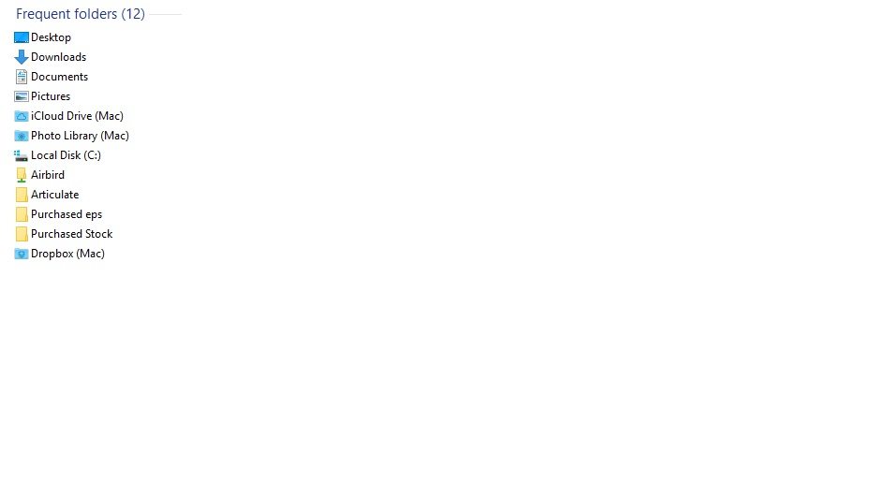
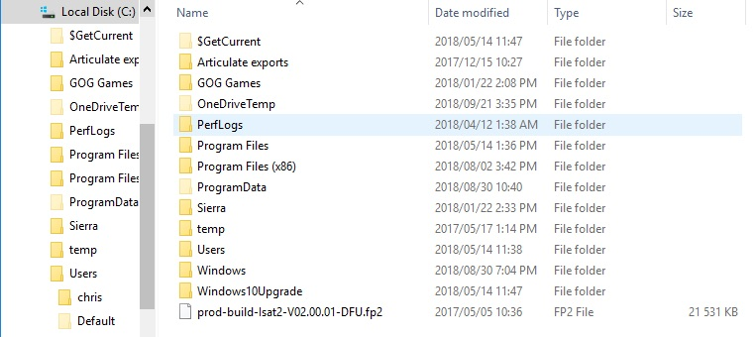

Folder / Location contents
This view changes according to what you have selected in the sidebar.
The image on the left shows the default view when explorer starts up - nothing is selected in the sidebar.
The second image shows the contents of the C:\ drive displayed as a list.
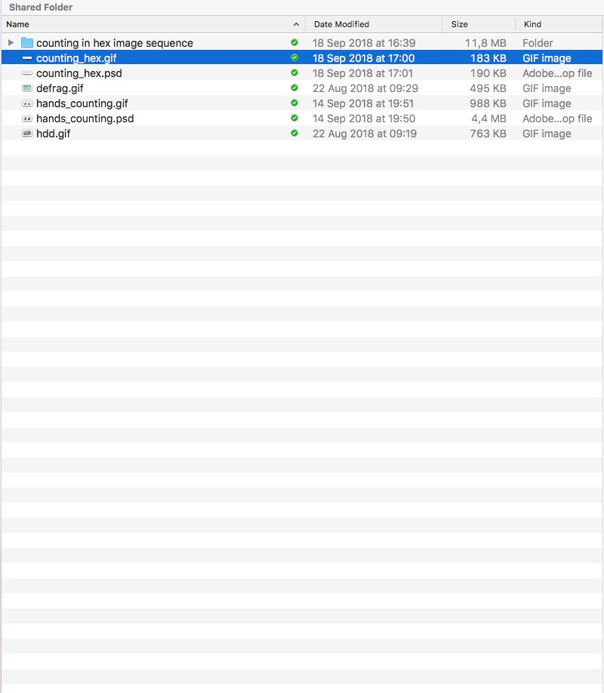

Folder / Location contents
This view changes according to what you have selected in the sidebar.
If the current selected item is a folder then its contents are displayed as a list, set of icons or in one of the other view modes supported by Finder.

Menu
These tabs give you quick access to common commands. The Home, Share and View tabs can be fixed in place like the ribbon in the MS Office apps (you will see a little downward arrow on the far right of the menu line - click it to get the ribbon view).
File Menu
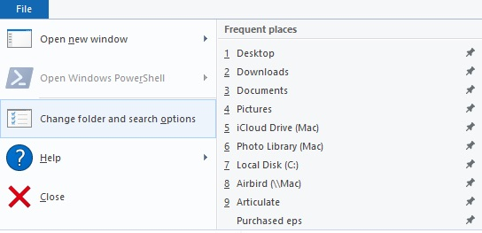
The File menu is a quick way to get to previous files and folders you have worked with
The first option allows you to create a new Explorer window so that you can work with files in two separate locations - and just drag from the one window to the other to copy / move the files.
Home Menu
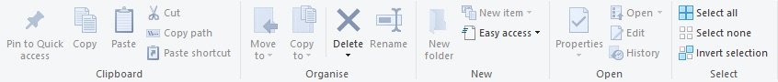
This ribbon allows you to do common tasks - such as copying, deleting and moving files
The first option (Pin to Quick Access) allows you to add the selected file / folder to the sidebar
Share Menu
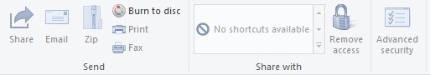
This ribbon allows you to quickly send a file by email, compress (zip) it, burn (write it) to a CD / DVD (if you have a writeable optical disk and a writing optical drive). You can even quickly print or fax the file.
View Menu
This ribbon allows you to change the way files and folders are displayed in explorer. Experiment with the settings to get to a view that you find useful for you.
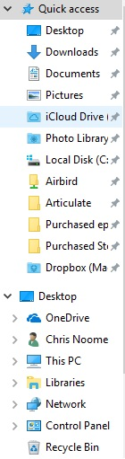

Sidebar
The sidebar starts off by listing all your quick access links. These are the locations (drives, folders, network drives and even files) that you access often.
You can add items to this sidebar by dragging them from the main view, using the Pin to Quick Access option from the View tab or by right clicking an item and closing to add to Quick Access.
When you open a folder or drive the item opens up to display its tree structure (see the image below).
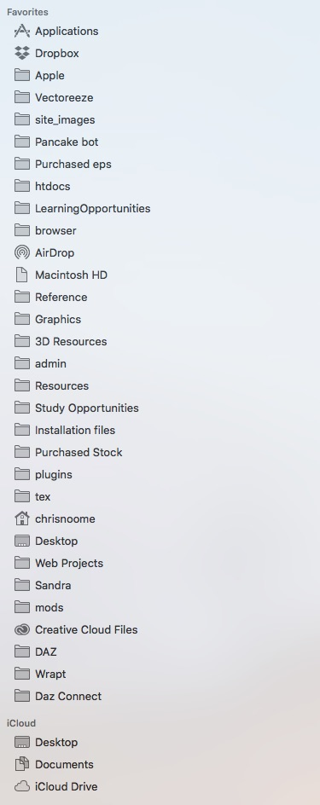

Sidebar
The sidebar starts off by listing all the locations (drives, folders, network drives and even files) that you access often.
You can add items to this sidebar by dragging them from the main view.
When you click a folder or drive the item opens up to display its tree structure.


Sidebar
The right hand sidebar shows summary information about the currently selected item. It will show a preview of any file that the OS's Preview app can open. It also displays extra information about the file at the bottom of the side panel.
This view can be hidden if you do not wish to see it.
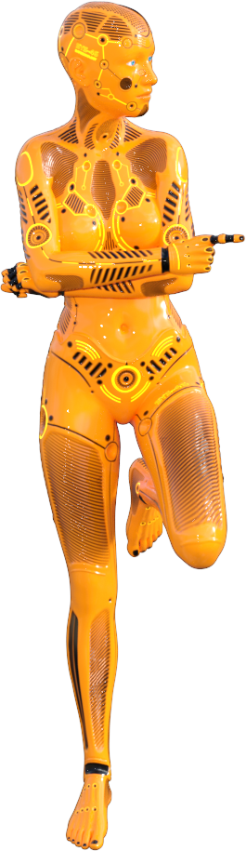

Keeping your storage in order
The CPU follows instructions stored in memory. It processes data that is also stored in memory.
When first switched on, the computer's memory is empty.
So, if the computer only works on instructions and data in memory, and when first switched on the memory is empty - how does the computer ever get to do anything?
Well, there's a special type of memory called ROM (ROM stands for Read Only Memory). This memory has its contents fixed (which means the contents remain in ROM even when power is off). When the computer is first switched on it gets its first instructions from ROM. These instructions check that the hardware is all OK (the POST or Power On Systems Test) and then it loads the OS from storage.
From there on, the computer behaves in a predictable pattern:
Instructions (i.e. software) are loaded into memory from storage when they need to be run.
Data collected from input is saved to storage so that it can be used later.
Data already collected is loaded from storage so that it can be worked on and processed.
Changes to data must be saved back to storage or they will be lost.
The pattern here is that storage is central to everything a computer does.
The more things you use a computer for, the more it relies on storage to keep the instructions and data available for use when needed.
Today's computers have (and use) multiple Gigabytes (if not Terabytes) of storage. That is a lot of data and a lot of files.
You need to know:
how the organisational structure of storage and file systems work.
how to use a file manager to manage your storage.
how cloud storage works.
how syncing between your computing device and cloud storage works.
Cloud storage is explained in the Chapter on Data Communications. The rest of these concepts are explained in the dropdowns below…
How file systems work.

How the OS manages files
NB: what follows is a bit of an alphabet soup. Don't worry too much about remembering all the different file system names mentioned below. What is important is that you understand that there are multiple file systems, that they have different rules about file names, etc - and that most OSs support multiple file systems.
The OS uses a file system to manage files kept on storage.
The file system is a set of rules that set out how files are named, how folders (or directories) can be structured, the largest file size that can be used, what attributes a file can have, and so on.
Examples that show these differences include:
FAT only allowed file names to have 8 letters with a three letter extension.
FAT32 allowed files to have names of up to 255 letters with up to 8 letter extensions.
The Linux ext (ext2, ext3, ext4) series of file systems is case sensitive - which means that "my it project.docx" is seen as a different file from "My IT Project.docx".
All OSs support multiple file systems - this is so that they can read and write files on storage created by different OSs or on older versions of the same OS.
For example, DOS and the first versions of Windows used a file system called FAT. Later versions of Windows used an improved version of FAT called FAT16 and then FAT32.
The default file system for Windows 10 is NTFS. BUT Windows 10 supports the older file systems as well.
The default file system for MacOS is HFS+ or APFS (for macOS High Sierra or later).
The default file system for Linux is ext4.
Most cameras and devices with memory cards tend to use either FAT32 or ExFAT.

File names and extensions
All current default file systems allow file names to be up to 255 characters long (including the extension - which allows extensions to be any length you like).
The purpose of the extension is to give the OS something to associate with a specific application - and so that you, the user, can make an informed guess about what the file contains (more about file extensions in that dropdown).
Naming a file properly is important. At the moment you create a file and whilst you are working with that file you will easily remember the file name and where the file is stored. BUT what happens 6 months, a year, 5 years later when you need to access the data in that file?
If the file has a short, cryptic name like "itidproj.docx" then remembering the file name - and finding the file on storage could end up being quite a mission.
"IT Project - Input Devices.docx" is easier to remember - especially if you make sure that all your IT project documents have names that start "IT Project". And finding the document becomes easier if you store it in a properly named folder.
NB: some Linux and macOS file systems are case sensitive - and some Unix and Linux file systems do not allow spaces in the file name (this is why some files you download from the internet have "%20%" in their names - the uploaded file has spaces in the file name and the OS removed the spaces and replaced them with "%20%" because 20 is the Hex value of a space in the ASCII / Unicode table).
If you are going to upload a file to the internet - especially files for web pages, it is best practice to keep the file name in all lowercase and to not use spaces in your file names - rather use the underscore "_" character instead.

The Root folder
Microsoft file systems (all the versions of FAT, exFAT and NTFS) represent your storage medium (or drive) as a letter. E.G. "C:\" or "D:\".
Your boot drive is usually the "C:\" drive.
Other file systems use the volume name of the storage medium (in macOS and Linux drives have names and your boot disk, for example is known as "Macintosh HD" in macOS.
Going to a drive letter or volume name in your file explorer puts you in the 'root' folder for that drive. All other folders and files are stored in this main root folder.

Folders (directories)
Folders are structures in storage that we create to organise our files.
A folder can hold both files and other folders.
Folders are arranged in hierarchies - the root folder is at the top. Folders inside the root folder are one step down in the hierarchy. Folders inside these folders are one step further down - and so on.
Just like files, you need to name your folders properly so that you can use your folder structure to easily find files that you are looking for.

File paths
A file path is the fully written out name and location of the file on the storage medium.
We use a file path as a shorthand to tell people where to find a file on their storage.
Let's say we want to know where to find our "IT Project Input Devices.docx" file.
The animated text will walk you through how to do this if someone gave you a file path (the text cycles through the explanation repeatedly, so don't fret if you arrive somewhere in the middle - just keep watching…).
The file manager

Managing your files with a GUI tool
Every OS has a file management tool.
In Windows this tool has been known as File Manager, Windows Explorer, File Explorer and now, in Windows 10, simply Explorer.
In macOS the file manager is known as Finder.
In Linux the different GUI environments tend to have different file managers - for example, the GNOME GUI uses the Nautilus file manager; the KDE GUI uses the Dolphin file manager.
Windows Explorer
The image displayed below explains the sections of the explorer window.
Click on / tap the hotspots (the coloured areas) for detailed explanations.
For more practical advice on file management watch the videos in the File Management videos at the bottom of this section.
[image unavailable: Image Map]
macOS Finder
The image displayed below explains the sections of the Finder window.
Click on / tap the hotspots (the coloured areas) for detailed explanations.
For more practical advice on file management watch the videos in the File Management videos at the bottom of this section.
[image unavailable: Image Map]
File Extensions

Linking files to Software
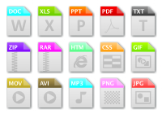
The file extension is the part of the file name that comes after the last period ('.').
The extension was created as a away to identify the contents of a file for both humans and computers.
As an aspiring IT professional you need to be able to know and recognise a wide range of file extensions as they are the clue that tells you what the file contains - and what type of software can be used to open it / work with its contents.
Explore the options below to learn about the most common file types you are likely to encounter…
Archived / Compressed files
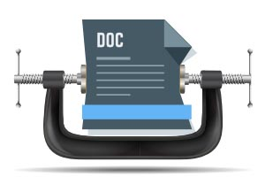
Compression is an essential part of modern computing.
Compression is finding ways to reduce the size of data.
This is done using complex mathematical formulae that search for and recognise patterns and substitute the patterns with symbols.
Compression is not only used to reduce the size of files on disk so that they take up less space. It is also used to reduce the size of data in communications. It is also used to reduce the size of media stored in files.
Archiving is collecting multiple files into a single container
(that usually looks like a file) for easy storage.
Let's say you want to send 27 documents related to a project you are working to a colleague. Sending 27 different files is tedious and could lead to confusion. So you archive the files by collecting them into a single unit and sending that unit. The receiver unarchives the received file and has the 27 different documents again.
Archiving and compression is usually combined into a single tool that gathers multiple files into a single container - and compresses the files to reduce the space taken up by the resulting container file.
In this section we talk about files that are compressed to save space on disk.
There are several different types of compression available - the most common in the Windows / macOS world is the .
zip
file. Linux users are more likely to encounter a .
tar
or a .
gz
file.
A list of the most common archived / compressed file types include (but is not limited to):
- .
Zip
/ zipx
Rar
.
Tar
/ tar.gz / gz
7z

Did you know
Disk images (.
iso
for Windows and .iso or .
dmg
for Mac) are compressed archive files. These files can be 'mounted' (i.e. added to the file system and treated as a storage device) by your OS and used as a virtual drive for installing software from.
Back to the top of this panel
Text files
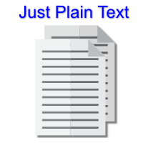
Text files are files that contain text.
The statement above may seem obvious, but text files can contain encoding (in text form) that let them store other types of data
For example you could - if you were mad enough - use a text file to hold the data for a picture. The text file could contain hex digits - where groups of hex digits could be combined to give the colour of a pixel.
This would be really inefficient, slow to read and result in a larger file - but it could be done!
In fact, there are many types of text file that contain this type of data - .html, .css, .csv, .rtf, .obj - and many many more.
Here is a list of commonly encountered text files:
- .txt and .rtf are text files that contain text written for humans by humans.
- .html, .css are text files that contain text written to be displayed in a browser (.html) and instructions for how that text should be laid out and formatted (.css)
- .csv is a text file containing data arranged in rows and columns with one line of text representing a row and commas used to separate the columns in a row. It is used to export / import data from spreadsheets and databases.
- .obj is a text file containing the wireframe form of a 3D object. .mtl is a text file containing the textures for the object. .fbx is another text file that contains the data for a 3D object and its textures. These file formats are used to let 3D graphics software import and export 3D shapes.
- .java, .js, .pas, .dpr, .py are all text files that human readable and editable programming instructions (i.e. source code)
There are many, many other examples of text files. The text file is the most universally used file type in the world of computers.
If you paid attention above you would see that text files are often used as a data transfer format - i.e. data is exported into a text file following specific rules. Any programmer following those same rules can then import that data into their own program.
Back to the top of this panel
Office Application files
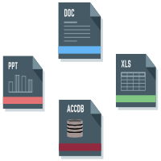
This category includes all productivity files - word processing, spreadsheets, presentations and databases.
The applications themselves are described in the section on Application Software.
The common file types are listed below:

Word Processors
- Doc / Docx - Microsoft Word
- Pages - Apple Pages
- Odt - OpenOffice Writer / LibreOffice Writer
- Txt - plain text file (no formatting)
- Rtf - Rich text file (basic formatting)

Spreadsheets
- Xls / Xlsx - Microsoft Excel
- Num - Apple Numbers
- Ods - OpenOffice Calc / LibreOffice Calc
- Csv
Comma Separated Values - text file (no formatting) - used for export / import and data exchange.

Presentations
- Ppt / Pptx / Pps - Microsoft PowerPoint
- Key - Apple Keynote
- Odp - OpenOffice Impress / LibreOffice Impress

Database
- ACCDB / MDB - Microsoft Access
- DBF - Dbase
- Db - Paradox / SQLite
- ODB - OpenOffice / LibreOffice Base
- CSV - Comma Separated Values text file used for import and export.
Back to the top of this panel
Graphics and Media files
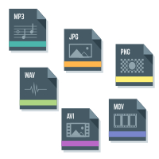
Graphics and media applications are discussed in detail in the section on Application Software.
Common file formats here are:

Bitmap Graphics
- Jpg / jpeg
A standard created by the Joint Photographic Experts Group (hence the name). A lossy compressed image - most common bitmap file type popular because of its small size. Cannot contain transparency.
- BMP
- PNG
Portable Network Graphics. A lossless compressed image. Larger than jpg files but can contain transparency.
- Gif
Graphics Interchange Format. Can only contain 8 bit colour images. Can contain animation.
- PSD
A Photoshop document - can contain multiple layers of graphics elements, transparency, text. File sizes are large. Usually needs to be exported into more common formats to be used.

Vector Graphics
- Ai - Adobe Illustrator
- Cdr - Corel Draw
- afDesign - Affinity Designer
- Odg - OpenOffice Draw / LibreOffice Draw
- Svg
Scalable Vector Graphics - plain text file used for import and export to exchange data between vector graphics apps. Web browsers can display SVG graphics and use of this file format on the web is increasing.
- Eps - Encapsulated PostScript - another common import / export and data exchange file type.
- Pdf - Portable Document Format. This file type can be used to import / export vector graphics as well.

3D Graphics
- Max / 3DS - 3D Studio Max
- C4D - Cinema 4D
- DAZ - DAz 3D
- LWO - LightWave
- Blen - Blender
- Obj
Text file containing data about an object - used for import & export
- FBX - Text file used for data import and export
- SKP - Sketchup
- DAE -

Video
- AVI
- MOV
- MP4
- WMV

Audio
- WAV
- MP3
- AAC
- OGG
- FLC
Back to the top of this panel
Font files
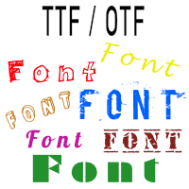
Your computer comes with some fonts pre-installed.
Some applications add new fonts to the system when they are installed.
There are two main types of font formats (and files) available:
- .TTF - This is a True Type Font
- .OTF this is an Open Type Font
A great source of free fonts is
Google Fonts
(which provides fonts that you can download and add to your computer - and which are used freely on the WWW.

Be careful how you use fonts
If you install fonts on your computer and use them in a document then you have to remember that when you send that document to someone else the fonts you use will not display correctly - unless that person also has the same font installed!
There is such a wide range of funky fonts out there that you might be tempted to download and install them all. Just remember that fonts take up disk and memory space and having too many fonts can actually slow down your computer!

NB: Most fonts are not free!
A font is like a set of images that someone has had to create. Just finding and copying a font from your friend is just as much a breach of copyright and piracy as stealing a game, a song or a video is!
Back to the top of this panel
Source code

Source code is programming instructions in a human readable form (i.e. a high-level programming language such as Java C++, Object Pascal, Python, etc).
Source code needs to be converted into instructions the computer understands (i.e. machine code / binary) by either a compiler or an interpreter.
The compiler / interpreter is part of the programming language.
As mentioned in the section on text files, source code is stored on disk as plain text.
All the colourful syntax highlighting, code completion, indentation, etc. are tools provided by the code editing tool (or IDE) you are using.
Examples of source code file types include:
- .pas - Object Pascal / Pascal source code. Delphi uses a project file - .DPR - to contain information about all the .pas files needed and used in a specific program. Lazarus (The OSS version of Delphi) does the same but its project file format is .LPR
- .java - Java source code. This can be compiled into .class and .jar files.
- .py - Python source code file.
- .js - Javascript source code file.
Back to the top of this panel
Executables and DLLs
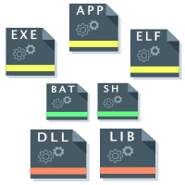
These are files that contain instructions for the computer to follow.
These files are also known as / called Programs / Software / Applications / Apps / Libraries and Scripts

Programs vs Libraries vs Scripts
A Program (Application / App) is a set of instructions that can be run by the CPU. It is created to solve a specific problem / complete a specific task.
- In Windows a program is a .Exe file. Much older DOS / Windows programs could also have the .Com extension.
- In macOS a program is a .app. This is actually a self-contained folder holding the executable file and all the resources it may need. If you explore the app package the actual executable file inside often has no extension at all.
- Linux is a lot more complicated - technically any file type can be executed in Linux. Officially .ELF is the type for a compiled executable file.
A Library is a set of programs that the cpu can follow - but it is not designed to complete a specific task.
Programmers put common, shared features used by multiple programs into a library.
If you write a program and need a dialogue box to open a file, you don't go and write all the code to do this job. Instead you link your program to a library and use the dialogue box included in the library. This way the same code is written only once but used by multiple programs, saving a lot of time and effort.
- Libraries in Windows have the .DLL (Dynamic Link Library) or Lib extension.
- In macOS and Linux libraries tend to have the .lib or extension.
A script is a text file containing instructions that can be sent to the CPU using an interpreter. Scripts are often text files containing a list of instructions for the CLI interface of the OS.
- In Windows / Dos scripts have the .bat extension.
- In macOS and Linux scripts usually have the .sh extension (they are often called shell scripts or Bash scripts).

What is Object Code?
Some people may call program files / libraries object code.
This is because they are differentiating between a source code file (which cannot be run by the computer) and the file created when you compile source code so that the computer can run it.
If your language is an interpreted language (e.g. Java, Python and Javascript) the source code never produces an object code file. It is loaded as a text file and the interpreter sends the instructions to the CPU one line at a time, as they need to be executed.
Back to the top of this panel
Converting between file types

Overcoming compatibility issues

As you may have noticed, most Apps store data in their own file format - with their own file extension. Sometimes Apps change their storage format in newer versions as they get additional features.
Generally speaking, Apps only work with their own file formats. Newer versions of apps are usually backwards compatible (they can open older versions of their own file type). For obvious reasons, older apps can not open newer versions of their file format.
This creates a compatibility problem. What if you create a file in MS Word and need to send it to someone who only has / uses LibreOffice Writer?
The solution is to explore the 'Save As' and or / Export options in the file menu. This will often give you a way to save a file in a format that the other software can open.
The other person will use the Open or Import options to get data from a file type that is not the default format.
NB: You need to make sure that you check at the bottom of the file dialogue to see what file formats are being displayed in the dialogue box.

Problems with Import / Export
Importing and exporting is always a compromise. Most of the time you will lose something in the process - usually the carefully crafted formatting and layout that took up so much more time than just creating the document itself.
This is still better than not being able to share the document at all though!

Video Links - File Management & File Types
We have selected and curated a set of videos on YouTube related to your course.
These videos are not created or owned by us.
They may display advertising and in some cases may contain limited amounts of swearing.

Notes for this Module
What to look out for and do in this module...
The FAQs are not questions that are likely to appear in exam papers - they are real questions that most people ask about the content.

FAQs for this module
Questions on File Management - and their answers...

Network Types FAQ
View the questions or type in the term you are looking for below…
No results were found

What is the difference between a file and a folder?
A file contains data.
A folder is a container that can hold files and folders.

What is the difference between copying a file / folder and moving / a file / folder?
When youcopy the original stays behind in the same location.
You end up with two copies of the file folder.
When youmove the file / folder is first copied to the new location and then the original is deleted.
You end up with only one copy of the file / folder.

What is the difference between a Directory and a Folder?
Nothing.
They are the same thing.
Directory is the term used in CLIs such as DOS and Linux.
GUIs tend to use 'Folder' because of the icon used to represent it.

When I drag and drop a file / folder am I Moving it or Copying it?
It depends.
If you drag and drop on the same storage device the OS will usually interpret this as a 'move' instruction and move the files.
If you drag and drop between different storage devices the OS will usually interpret this as a 'Copy' instruction.

Sometimes I am given the option to merge folders - what does this mean?
When you copy or move a folder to a location that already has a folder with the same name you can be given the option to 'merge' the two folders.
If you choose to merge the OS will only keep the newest versions of files that are in both folders - and include all the files from both folders into a single folder with the same name.

My storage has got lots of small files on it. I add them up and the total do es is less that the used space on my storage. Is something wrong?
No.
Remember the smallest 'block' of storage used by most OS's is 4Kb.
Let's say you have 10 files of 1Kb each. Each file takes up 4Kb of storage space, even though the OS will correctly tell you that the size of the data is 1Kb.
The total used space for these files is therefore 40Kb even though the actual data is only 10 Kb.
The difference between these two figures is known as 'slack'.

